Joystick Mapping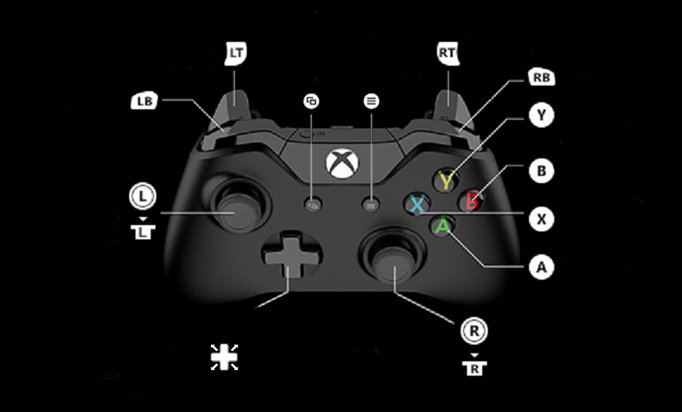

*RT: Intake*

*LT: Reverse intake*

*RT + LT: Driver assist*

*RB: Manual arm control up*

*LB: Manual arm control down*

*A: Arm position cycle down*

*B:*

*X: Arm position cycle up*

*Y:*

*R/L Joystick: Tank drive*

*D-Pad Up: Wrist up (90 degrees)*

*D-Pad Right:*

*D-Pad Down: Wrist down(0 degrees)*

*D-Pad Left:*